****Contact Info:**

|  |  |
| --- | --- |
| **Pregnancy and Parenting Support** | **Family Connection Centre /**  **Terrace Child Development Centre** |
| 4665 Park Avenue | 2510 South Eby Street |
| Terrace, BC V8G 1V9 | Terrace, BC V8G 2X3 |
| Phone: (250) 635-1830 | Phone: (250) 635-9388 |
| Fax: (250) 635-1501 | Fax: (250) 638-0213 |
| Email: b.b@telus.net | Email: cdct@telus.net |
| **Momentos de Evasion: PRODUCTOS TERMINADOS (OCTUBRE Y ...**Hours: 9:00 am – 4:00 pm | Hours: 8:30 am–4:30 pm |

|  |  |
| --- | --- |
| **Pregnancy and Parenting Support** | **Family Connection Centre /**  **Terrace Child Development Centre** |
| Building Healthier Babies Group | Behavioural Support Services |
| Breastfeeding Support | Developmental Consultant |
| Toddler Group | Early Years Program |
| Parenting Support | Family Support Worker |
| Prenatal Education | Inclusive Child Care Program |
| Vitamins & Grocery Cards | Occupational Therapy |
|  | Physiotherapy |
|  | Speech & Language Therapy |

**Mission Statement**

****The Terrace Child Development Centre is dedicated to providing resources, support and education for children and families to grow and thrive.

Our staff work together

to support you and your family.

**History:**

The Terrace Child Development Centre (TCDC) is a non-profit registered charity operated by a volunteer Board of Directors.

The Centre was started by a small group of concerned parents and community members. The Child Development Centre has been serving children and families in Terrace and area since 1974. Eby Centre opened September of 1977. The downtown location of Park Centre opened in 2000.

For more detailed information about these programs and the services they can provide please refer to our website.

**www.terracechilddevelopmentcentre.com**

**Ethical Guidelines:**

* We will speak and act towards all clients and their families with respect and dignity.
* We respect each family’s unique values, culture and beliefs.
* We respect each family’s right to confidentiality and privacy.
* We implement services that are considered Best Practice by experts and research.
* We respect the right of clients to have access to complete information about our programs.
* We respect the right of clients to make decisions for themselves.
* We respect the right of clients to ask questions and have them answered to the best of our ability.
* We respect the right of families to experience freedom from abuse, financial or other exploitation, retaliation, humiliation and neglect.

**Privacy and confidentiality and your right to information:**

Information you share is private. You choose what to share and who to share it with. You also have the right to ask staff to access information from your client file as needed.

**Responding to Child Welfare Concerns:**

All of us- families, communities and service workers-share the responsibility for the safety and wellbeing of children. That means we must work together and, if we suspect that child abuse or neglect is taking place, we must report it to a child welfare worker, Ministry of Children and Family Development (MCFD).

**Your Rights & Responsibilities:**

**You have the Right:**

1. To access services as it benefits you and your family.
2. To be informed of the advantages and risks of proposed services.
3. To receive or decline services.
4. To know that information you share with us is private and will be kept confidential.
5. To access information in your client file at any time.
6. To express your thoughts, opinions and/or concerns about the services we provide.
7. To be recognized as a unique individual with strengths, knowledge and life experience that demands respect and dignity.
8. To set the direction in developing goals and determining the type of service delivery that meets your family’s needs.
9. To know the process of making a formal complaint.

**It is your Responsibility to:**

1. Provide consent for services.
2. Make informed decisions.
3. Decide who we share your information with.
4. Tell us what you and your family need.
5. Express yourself in a way that helps you get what you need while being respectful of others.
6. Participate as an active team member.
7. Ask questions and ask for help when needed.
8. Let us know if you are unhappy with our services.

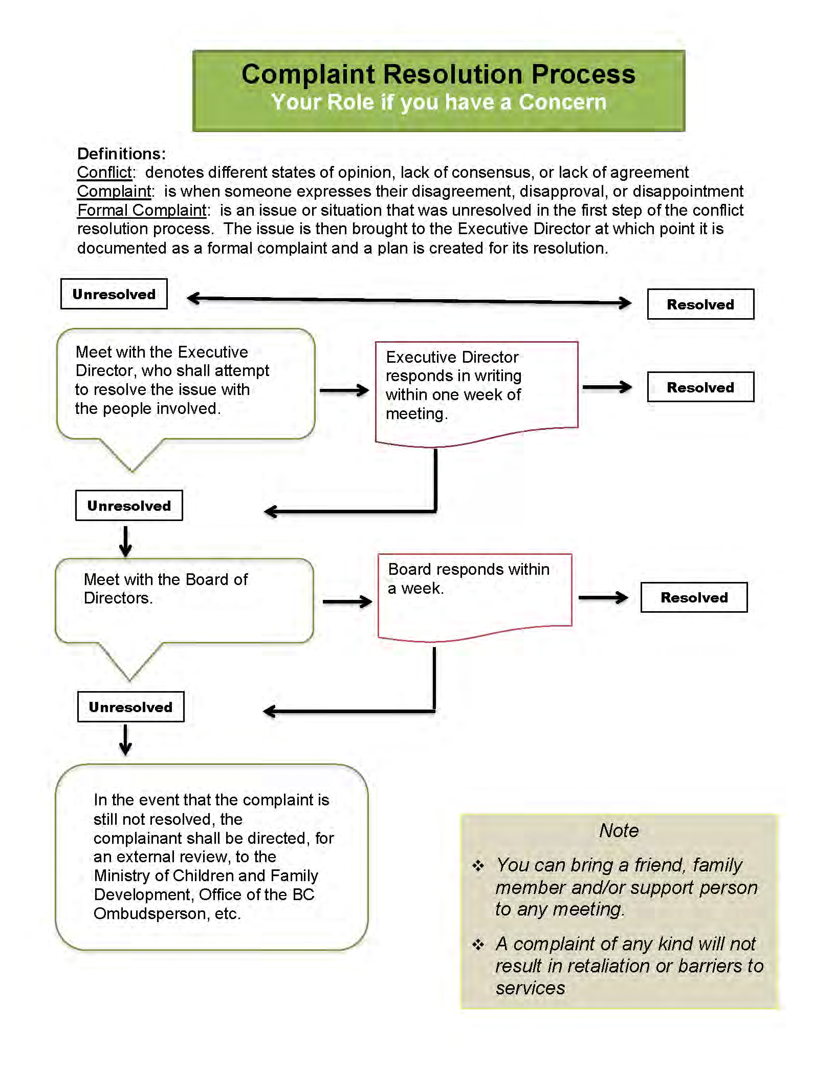**Health and Safety:**

The Child Development Centre has a Health and Safety Committee to ensure the wellbeing of staff and families who attend programs. Both buildings are inspected regularly and safety drills are held so that potential hazards and risks are dealt with promptly.

All staff are trained to handle accidents, emergencies and building evacuations. Please followtheir direction in the event of an emergency. For your safety, an emergency plan is posted in both of the Child Development Centre locations.

****Staff will contact appropriate services for support if someone in the building becomes agitated and/or violent.

**Statement of Diversity:**

The Child Development Centre acknowledges and respects the value of a diverse community. The Child Development Centre recognizes that the scope of diversity includes gender, race/ethnicity, family status, age, mental/physical abilities, sexual orientation, religious/faith beliefs, socio-economic status, and occupational status.

**We believe that parents/guardians:**

* Are the experts of their children
* Want to be good parents/guardians
* Want to feel proud of themselves
* Have the potential to learn and change
* Are responsible for their own actions and choices

**A strength-based/family-centered approach means:**

* Families and program staff work together to plan visits
* Time is spent discovering the strengths and skills of participants
* ****Families identify the goals they want to work on and staff support them in reaching those goals

**The Terrace Child Development Centre staff will:**

* Listen to you
* Treat you with respect
* Affirm every family’s values, customs and beliefs
* Communicate openly and honestly
* Provide complete and unbiased information
* Acknowledge individuals and family’s needs and concerns
* Build on families’ strengths



**Accessibility:**

We will try to make it possible for all eligible persons to access our programs. Our buildings are easy to get to and are wheelchair accessible/friendly. Our staff is welcoming and helpful. If at any time you have difficulty getting to a program or understanding information about the programs, let us know. We will do what we can to help.

**Accessing Other Community Services/Supports:**

We may be able to help you access other resources that you need. Please let us know and we will try to answer your questions.

**Students:**

The TCDC accepts students on practicum placements from high school, college and university. A staff member supervises each student. All students are required to have successfully completed a criminal record check prior to commencing their placement.

**Cancellations:**

If you need to cancel a visit, please let us know as soon as possible and we will work with you to reschedule.

If a staff member needs to cancel a visit, you will be contacted as soon as possible to reschedule.

**Fundraising:**

Any fundraising that is not related to the TCDC, must occur outside Centre hours or be approved by the Executive Director.

